**Weather Data Analysis**

Student’s Name

Institutional Affiliation

Course

Professor’s Name

Date

**Weather Data Analysis**

**Objective**

This project's main objective is to develop a MATLAB program that will help analyze the weather data and offer trends between the temperatures and the amount of rainfall over a specific time interval. The program, developed in MATLAB, allows the user to perform the computational operations using a set of built-in tolls, to use the tools for analyzing the seasonal variations, and to reveal the statistical characteristics of the given data sample. The analysis is broader in that it will help make decisions on climate patterns for agriculture, urbanization, disaster preparedness, and environmental conservation.

The project has other important practical uses when working with the analyses of temperature fluctuations or rainfall distribution. For instance, understanding temperature changes in different seasons may enable a person to find out when various crops need to be planted, or information about rainfall patterns can teach a person when to ration water. Furthermore, the work also makes one understand that MATLAB can handle various forms of data, manage large data, analyze the data better, and present the result with the help of graphs and statistics.

**Methodology**

The data for this project is contained in a CSV file named weather_data.csv. This file includes comprehensive weather records for two years, with monthly data structured into three key fields that serve as the foundation for analysis:

1. **Month:** This field keeps the name of the months starting from January to December. It provides a categorical view of time, which significantly aids the process of sorting data into a coherent time framework. This field also helps users navigate through content with its month-based navigation and filtering capabilities.
2. **Temperature (°C):** This field holds the typical monthly temperature in degrees Celsius throughout the year. In this case, it is applied when analyzing temperature changes and establishing seasons, variations, irregularities, and climate.
3. **Rainfall (mm):** This record field contains the total rainfall measured in millimeters that occurred in a given month. It is useful as an aspect of rainfall, especially when there is excessive or an absence of rain for some time. Such data is helpful in environmental surveys, research, water management, and resource and disaster planning.

The project uses MATLAB’s capabilities effectively for the following tasks:

1. **Data Loading and Preprocessing**

The program first inputs the dataset from the local drive using MATLAB's readtable function to ensure all data read is clean and valid. In the data set, blank or null values are filled with zeros to ensure that computations are conducted correctly. The data is cross-checked, and any deviation from the conventional standard is usually indicated. It helps to confirm that the data set is all set for analysis to be conducted on it.

1. **Statistical Computations**

The program allows calculations of simple arithmetic averages, minimums, and maximums for temperature and rainfall. These metrics give the general picture and provide an understanding of critical situations. It also allows users to choose a specific month for which they want to see the statistics, which can help compare seasonal changes.

1. **Visualizations**

Clear visualizations are generated to represent trends effectively:

* **Line Plots:** Present temperature variations within months, stressing the seasonal shifts.
* **Bar Charts:** List down rainfall for each month to be analyzed to identify disparities quickly.

These are interactive visualizations with titles, labels, and grid lines facilitating easy understanding of the images.

These features have been integrated modularly, allowing for a sound, effective, and sustainable program.

**Implementation**

The program is designed with the following core features:

**Data Input**

The program reads weather data from a CSV file using MATLAB’s readtable function. Missing values are replaced with zeros to ensure calculations are accurate. The data is divided into:

* A numeric matrix containing temperature and rainfall values.
* A cell array for the month names.

**User Interaction**

The main script uses a menu-driven interface to allow users to choose from several options:

1. **View Data Summary**:

* Computes overall statistics for temperature and rainfall.
* Results are displayed in the Command Window.

1. **Analyze Specific Month**:

* Prompts the user to select a month.
* Displays detailed statistics for the chosen month.

1. **Visualize Trends**:

* Generates two plots:
  + - A line plot showing temperature trends over the two years.
    - A bar chart illustrating monthly rainfall totals.

1. **Save and Load Data**:

* Enables users to save the current dataset to a .mat file and reload it later.

1. **Exit**:

* Terminates the program gracefully.

**Error Handling**

The program includes robust error-handling mechanisms:

* Ensures the file is correctly formatted and accessible.
* Validates user input at every step, preventing crashes due to invalid selections.

**Plots and Visualizations**

The program creates clear and detailed visualizations:

1. **Temperature Trend**:

* A line plot showing temperature variations across months.
* Includes titles, labeled axes, legends, and grid lines.

1. **Rainfall Trend**:

* A bar chart depicting the total rainfall for each month.
* Enhanced with titles, labels, and grid lines for readability.

**Results**

The program outputs the following:

1. **Statistical Analysis**

* The Command Window displays summaries for all data or specific months. For example:

Overall Weather Statistics:

Average Temperature: 24.90 °C

Max Temperature: 33.40 °C

Min Temperature: 15.50 °C

Total Rainfall: 94.80 mm

Average Rainfall: 3.95 mm

Max Rainfall: 39.80 mm

Weather Statistics for February:

Average Temperature: 28.90 °C

Max Temperature: 30.90 °C

Min Temperature: 26.90 °C

Total Rainfall: 3.60 mm

1. **Visualizations**

* **Temperature Trend**: A line plot highlighting seasonal temperature variations.
* **Rainfall Trend**: A bar chart showing monthly rainfall totals.

Below are the example plots generated by the program:

**Figure 1**: Temperature Trend Over Two Years

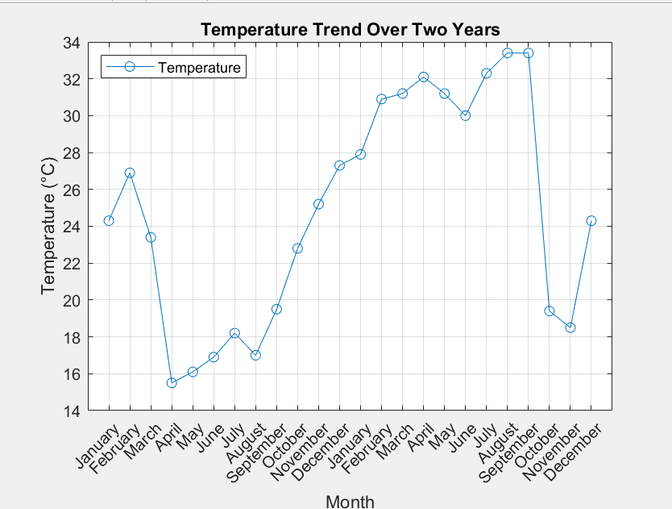

**Figure 2**: Monthly Rainfall Trend

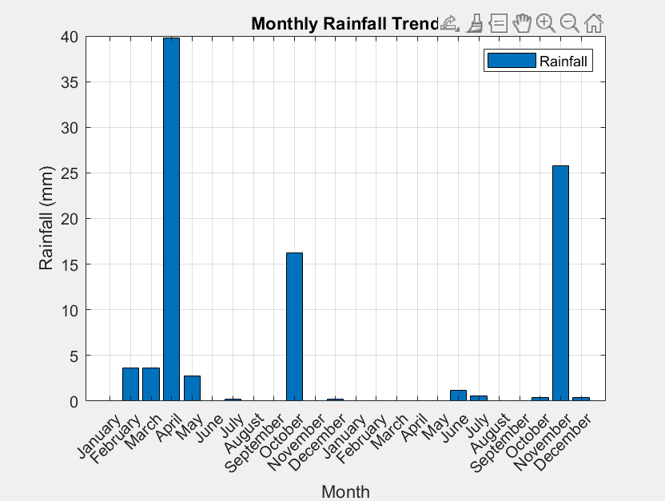

**Challenges and Solutions**

1. **File Handling**:

* **Issue**: Ensuring the CSV file is formatted correctly.
* **Solution**: Added error handling to check for invalid file paths or non-numeric data.

1. **User Input Validation**:

* **Issue**: Preventing crashes due to invalid user inputs.
* **Solution**: Implemented input validation for menu selections and numeric data.

1. **Plot Readability**:

* **Issue**: Basic plots lacked clarity and detail.
* **Solution**: Enhanced plots with titles, labels, and legends and saved them as images.

**Conclusion**

In conclusion, this project clearly illustrates how MATLAB can be used to analyze and interpret weather data, particularly concerning temperature and rainfall. The ability to access and modify the program with future changes, improvements, or add-ons is made quickly with the program's cohesive and constructed structure. The program is easy to use and extensively interacts through a simple menu-driven system. Thus, it can be used by anyone with any level of computer literacy. Problems such as missing data, input validation, and obtaining readable plots are addressed to provide accurate results. Statistical summaries coupled with graphical displays provide accurate results of seasonal weather, which aids in decision-making practices in areas like farming, city design, and meteorological research. This project demonstrates the applicability of MATLAB as a tool for solving various real-world data analysis problems. It provides a good foundation for developing the corresponding tools in further fields.

**Appendix**

* **Project Files**:
  + weather_analysis.m: Main script for program interaction.
  + load_weather_data.m: Loads and preprocesses weather data.
  + calculate_stats.m: Computes statistical summaries.
  + plot_trends.m: Generates temperature and rainfall plots.
  + save_weather_data.m: Saves current data to a .mat file.
* **Dataset**:
  + weather_data.csv: Two years of monthly weather data.